CST2120

**Web Application and Databases**

Damien Maujean

M00843707

Coursework 1- Second submission

Contents

1 Table of Figure 3

2 Login Page 4

3 Rules pages 4

4 Game Page 5

5 Leader board Page 7

# Table of Figure

Figure 1 - Login Page 3

Figure 2 - Rules Page - part 1 4

Figure 3 - Rules Pages - part 2 4

Figure 4 - Game Page - Part 1 5

Figure 5 - Game Page - Part 2 5

Figure 6 - Leaderboard Page - Part 1 6

Figure 7 - Leaderboard Page - Part 2 6

# Login Page

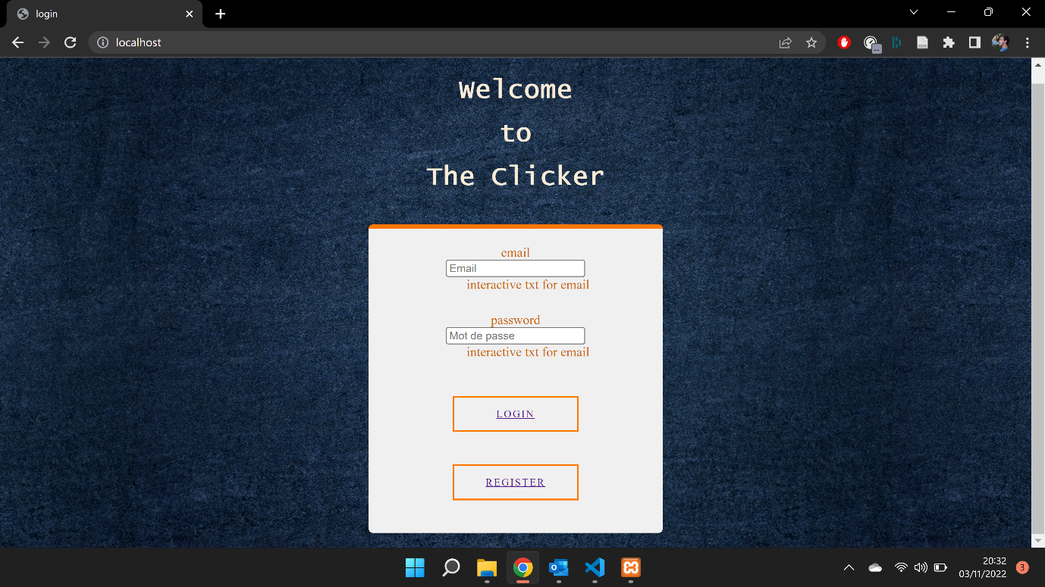

Figure 1 - Login Page

# Rules pages

Note: In this page was suppose to be display a current try of the game, since the game is not developed, this picture is display)

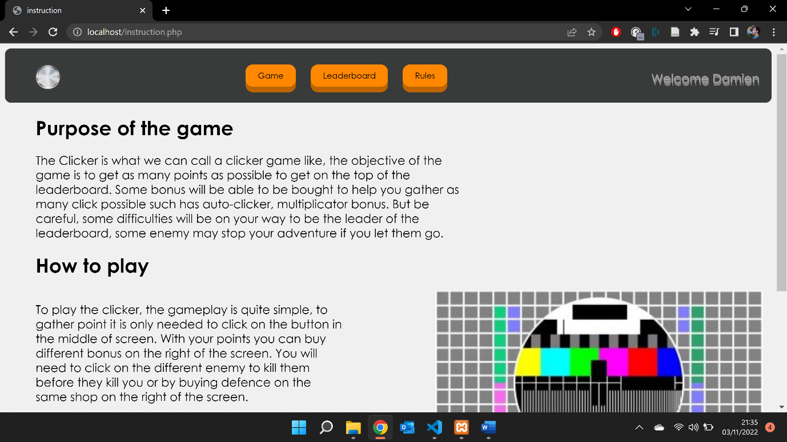

Figure 2 - Rules Page - part 1

Figure 3 - Rules Pages - part 2

# Game Page

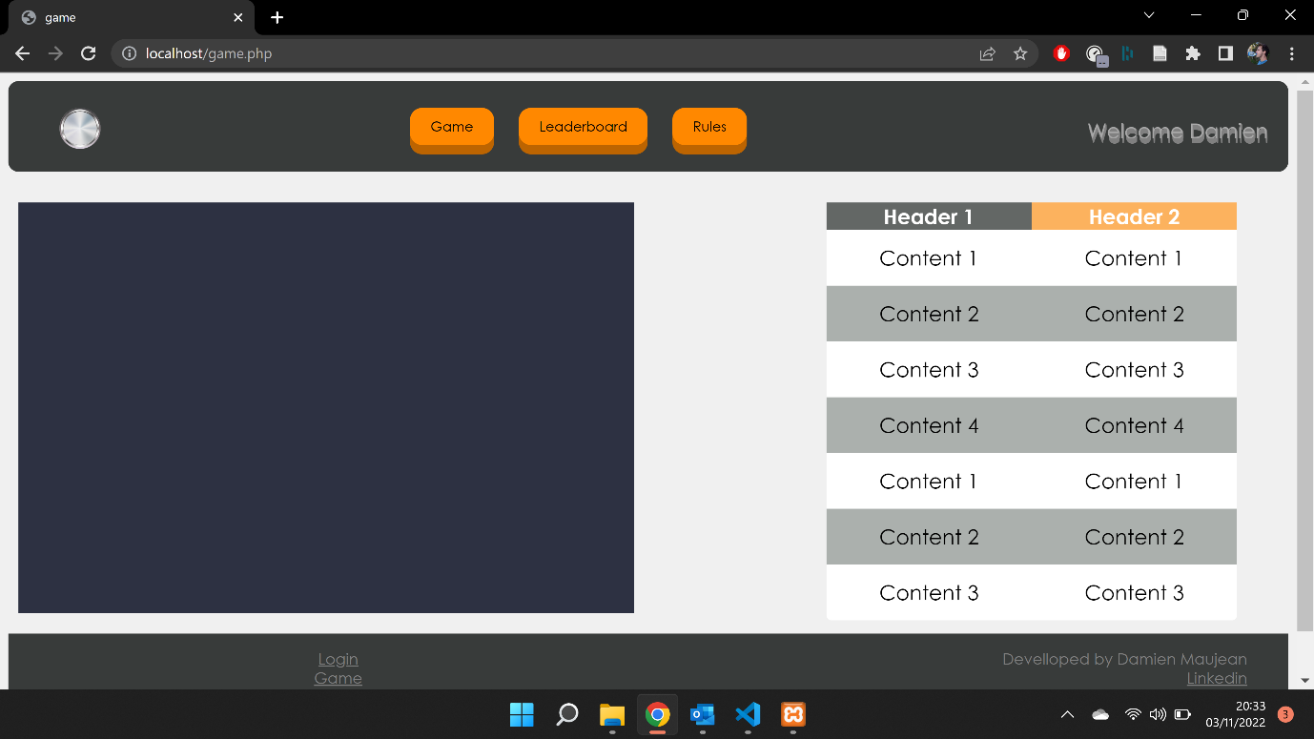

Figure 4 - Game Page - Part 1

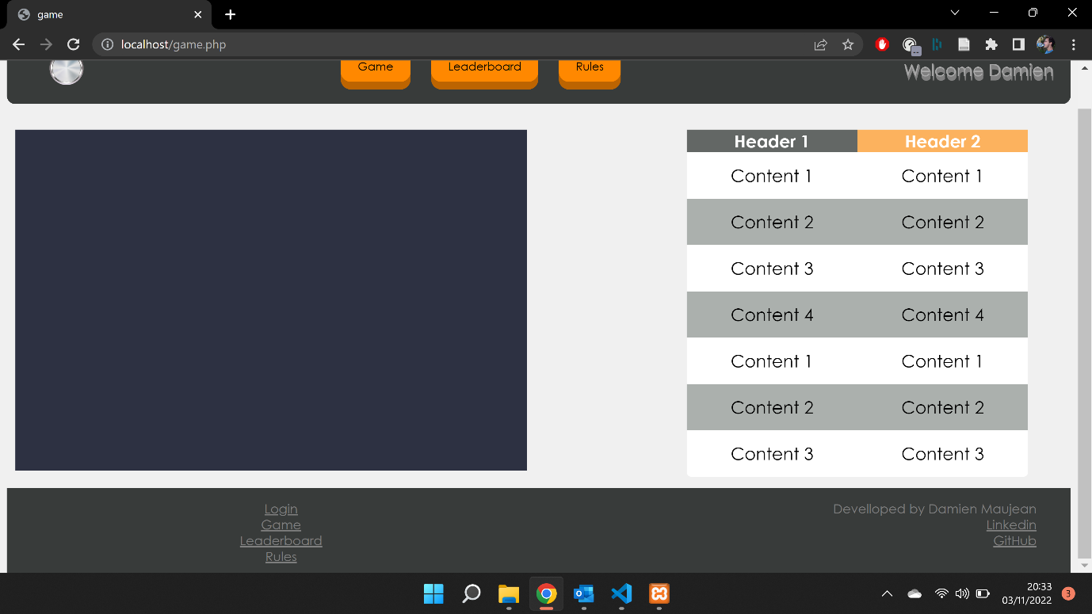

Figure 5 - Game Page - Part 2

# Leader board Page

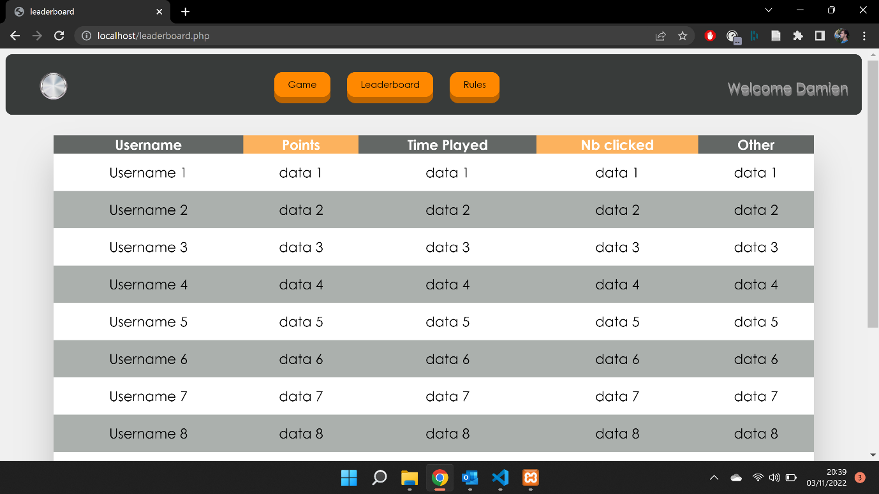

Figure 6 - Leaderboard Page - Part 1

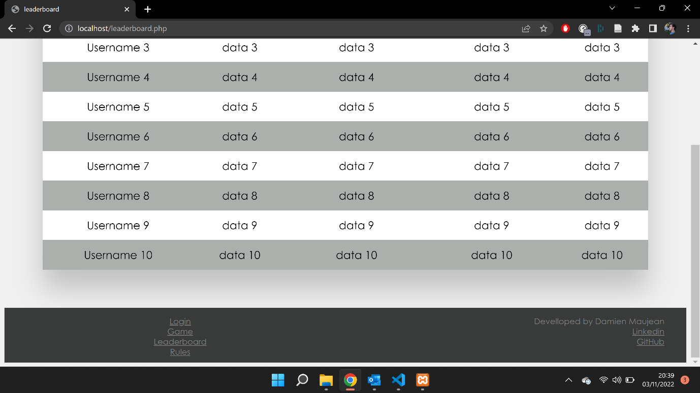

Figure 7 - Leaderboard Page - Part 2